The main purpose of the plant photos are to 1) document new or unknown plants that could not be confidently identified in the field, 2) provide data continuity if discrepancies are found later in species data, and 3) used as a reference for crews in future years to help with plant identification.

**Workflow for plant photos:**

1. **Photo taking:** Crews may take photos of plant specimens on smartphones, camera, or other device. Most often, I&M field smartphones will be used. Crew members are encouraged take photos with a personal phone if they choose to, with the understanding that their phone use in the field is at their own discretion and risk.

When taking photos of unknown plants it is better to take more photos than not enough. Photos of unknown plant specimen should include a focus on distinct features such as fruits, flowers, leaves, lifeform and habitat. Ferns should include photos of abaxial and adaxial sides, sori, and scales.

While in the field: Unknown plant should be recorded on Form 3 (Presence /Absence). Unknown plant records on datasheet should be given a unique name (e.g. Unknown Tree 1, Acacia sp., etc.) and are tied to the corresponding photos by recording the camera used and time the photo was taken. Unknown plants should also have a description/notes recorded to help identify species. Form 3 will also have a space to indicate if a sample was taken to assist in identification.

If an unknown species is seen in multiple plots but assumed to be the same, use the existing google drive photos to verify that it is in fact the same species and if easier for the crew record it using the same designated unique name. If there is any uncertainty, record as an unknown with a new unique name, note that it looks similar to another unknown (e.g. looks like unknown tree 1 from plot F2), and take photos.

2. **Photo upload:** After returning from the field, crew lead should upload I&M device photos and crewmembers should upload their photos from the day to a shared drive using wifi or wireless phone network. Google drive functions an easy to access location to put photos where all crewmembers can reference both in the field and in the office.

3. **Data management Google Drive:** The photos on google drive should be named with the same unknown alias used on the datasheet to ensure proper species identification. The date and timestamps are pretty reliable on smartphones and imbedded in the photos metadata.

Change iPhones to take pictures as .JPG instead of .HEIC this will have to be converted.

Online converter: <https://heictojpg.com/>

IT approved software for converting: <https://imazing.com/heic>

4. **Data management excel spreadsheet:** All unknown plants for each plot will have a record within the "unknown plants" spreadsheet which will be updated throughout the season. This spreadsheet will reside in the Google Drive and/or I: drive and will link all the pertinent information related to the unknown and its eventual identification – Including information like plot #, date, unknown alias, camera, datasheet notes, timestamp, photo name, identified species name, who performed the species ID, etc. When a photo is positively ID’ed then the name of the photo can be updated to the corresponding 6-letter code (or entire scientific name if not in the database).

Standardized naming convention for plant photos:

Photos identified to species:

(example)

CARPAP_1

CARPAP_2

etc.

Photos identified to genus or higher taxonomic level, please write out full family or genus:

(example)

Rubiaceae1_1

Rubiaceae1_2

Rubiaceae1_3

etc.

("Rubiaceae1" used because there might be more than one unknown Rubiaceae in a plot)

Same method for photos only identified to unknown lifeforms:

(example)

Unk_Tree3_1

Unk_Tree3_2

Unk_Tree3_3

See unknown plants spreadsheet for full list of accepted naming conventions

5. **Backups to I Drive:** Once every other week the google drive photos needs to be backed up to the I drive. I: drive IDrive at [..\..\..\Images](../../../Images) from here choose appropriate \sample year\park\Plant Photos\sampling frame folder\Plot folder. Check when photos were last backed up and try your best not to create duplicates or overlook photos.

Save the spreadsheet in the I drive. I: drive IDrive at [..\..\..\Images](../../../Images) from here choose appropriate \sample year\park\Plant Photos\sampling frame folder using the current date as the suffix (_YYYYMMDD).

6. **Finalizing spreadsheet and photo folders:** As time allows, field crew should be identifying unknown species.

After the field portion of the season is complete the final download from the google drive can occur. At this time the google drive is no longer used and the photos will be moved onto the I: drive only.

Final check of the spreadsheet and the plant photos on the :I drive (I: drive IDrive at [..\..\..\Images](../../../Images) from here choose appropriate \sample year\park\Plant Photos\sampling frame folder\Plot folder)

* Open both the photo folder and the spreadsheet.
* Ensure that records on the spreadsheet match the photos in the folder and vice versa.
* Custom sorting the spreadsheet by Date, then Plot#, then Photo time allows proofing using chronological order.
* Use Bulk Name Utility to rename multiple plant photos of the same species.

Example using Bulk Rename Utility

1. Paste the path to the photos in the address bar.
2. Select all the photos of Papaya.
   * Select multiple photos to edit within Bulk Rename by holding Shift and selecting the group of photo files (or individually selecting files by holding Ctrl).
3. Type "CARPAP_" into the Name box.
4. Click "Suffix in the dropdown from the Number box.
5. Click the "Rename" button.

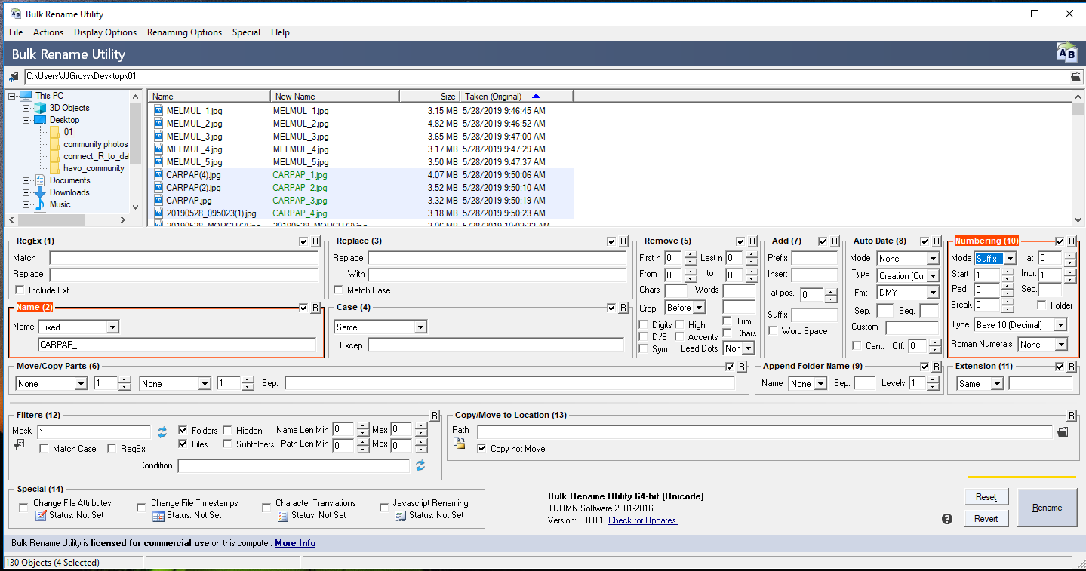

It will help to organize the photos by "Date Taken" within the bulk rename utility. This can be accomplished by doing the following:

1. Click the "Renaming Options" menu button,
2. Select "ID3/Exif Data...", then selecting "Extract Edif Data (Photos)".

Plant Photos and spreadsheet will be transferred to digital library after completion of data certification.

7. **Database/ Public Sharing:** The plant photos can be uploaded to a I&M project folder in iNaturalist for public sharing, for future reference for field crews, to query photos (for example: find all species photos from I&M in WAPA in the family Fabaceae). iNaturalist will update species and family name changes, allows photos to be displayed in a spatial map format, and the public can contribute suggestions for species IDs. This could also be a great format for the vegetation program to do some science communication.

Project site for AMME: <https://www.inaturalist.org/projects/pacn-vascular-plants-of-american-memorial-park>

Project site for WAPA: <https://www.inaturalist.org/projects/pacn-vascular-plants-of-war-in-the-pacific-nhp>

Shared Veg Account:

user: pacn_plants

pass: NPS1916

Instructions:

8. **Future monitoring:** Before the start of a new field season (for example WAPA year 2024), the folder from the I drive containing the plant photos is uploaded back onto a google drive (or latest technology used by crew) and a new folder structure for ‘2024’ is created so that new unknowns can be added and old photos can be referenced from the same folder location.